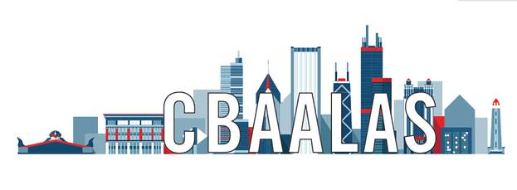

2019 Send-A-Tech to National AALAS Award
October 13-17, 2019 in Denver, CO

The Awards Committee is soliciting nominations for the Send-A-Tech to National AALAS Award. The award includes meeting registration, transportation, lodging, and a stipend for food and miscellaneous travel expenses. The purpose of the award is to increase technician involvement in laboratory animal science and to encourage and support technicians who perform a vital role in the field.

Nominees for this award must meet the following eligibility criteria:
1. Current member of CBAALAS having joined or renewed membership by April 1, 2019.
2. Must not hold a current elected or appointed position on the CBAALAS Council.
3. Must be an Animal Care Technician, Animal Health Technician, or Veterinary Technician
who is directly involved in the care of laboratory animals with a minimum of 1 year of
experience.
4. Must not be in a managerial position (e.g. clerical staff, managers, or supervisors).
5. Has not attended a National AALAS Meeting.
6. Self-nominated.
7. Upon return from the meeting, the recipient will give a 15 minute presentation at a
CBAALAS General Membership Meeting about their experience at the National Meeting.
The following items must be received as one nomination packet by no later than July 3, 2019.
1. Completed nomination form.
2. Nominee’s resume.
3. Self-nomination letter stating why s/he deserves to go to the National AALAS Meeting.
4. A letter of support from the nominee’s manager/supervisor that must state that the
nominee will be permitted to attend the National Meeting should s/he be selected for
the award.
5. Optional: A maximum of three additional letters of support will be accepted but are not
required.
The Awards Committee will review the nominations and make their selection on the basis of merit. In the event the Awards Committee cannot come to an agreement or in the event of a tie or candidate disqualification, the CBAALAS Council will vote and make the final decision. The winner will be notified by August 1, 2019. Nominations received after July 3, 2019 will not be eligible for consideration.

2019 CBAALAS Send-A-Tech to National AALAS Nomination Form
Name of Nominee: |  | Phone Number:
Institution: | Email Address:
Number of years in the laboratory animal field (Min. 1 year required):
Have you attended a National AALAS Meeting before? No Yes (Ineligible for award)
Do you hold a current CBAALAS membership? Yes No (Ineligible for award)
Number of years you have been a member of CBAALAS:
Number of years you have been a member of AALAS:
Highest education level achieved:
Highest AALAS certification achieved:
If you are selected for this award are you interested in being featured in the Member Spotlight section of the CBAALAS newsletter with a photo and Q&A session?
Yes No
Please provide a brief description of your experience as a technician:

Areas of Special Interest
1)

2)

3)

Special Training
1)

2)

3)

Publications, presentations, awards, prior nominations:

Pre-Submission Checklist
Review all your documents carefully and fill in the checklist below to ensure your packet is complete prior to submitting the nomination. This will also help the Awards Committee to confirm they have received all of the documents you intended to include in the packet.
Required
The nominee meets all eligibility criteria.
The nomination form has been filled out and attached.
The nominee’s resume is attached.
A self-nomination letter is attached.
A letter of support from the nominee’s supervisor/manager is attached and states the
nominee will be permitted to attend the meeting if selected for the award.
Optional
A maximum of three additional letters of support are attached.
How many optional letters of support are attached? 1 2 3

Have all the authors of letters of support provided their contact information in their letters?
Yes No
If no, please provide the missing contact information here:
Name: | Phone: | Email:
Name: | Phone: | Email:
Name: | Phone: | Email:
Name: | Phone: | Email:
Return completed nomination packet by 7/3/2019 to:
Cara Strathmann,
CBAALAS Secretary
Email: CHatten@northshore.org
Phone: 224-364-7979
Please send the nomination form and ALL supporting documents as one packet. If you have access to a scanner, please scan and send all documents combined as one file via email.

